MQ2 Gas Sensor With Nokia 5110 LCD
Description:- In this project we are going to calibrate LPG, CO and Smoke PPM in the air and display these values on the Nokia 5110 LCD screen.
In this project when you will exhale breathe on it or put a cigarette lighter near it then LCD screen reading would change.
Component required:- This project is based on the Arduino uno board and we are interfacing MQ2 gas sensor with Nokia 5110 LCD so we would required component which are described below.
Components list:-
- Arduino board.
- Arduino software.
- MQ2 gas sensor.
- Nokia 5110 LCD.
- Bread board.
- Jumper wires (M-M: 2, M-F: 11)
Libraries required

- Nokia 5110 LCDlibrary included
Add these libraries to your arduino IDE using below steps: -
- Unzip the downloaded library and copy extracted folder.
- Now go to Arduino Installation directory.
- Then go to libraries folder and paste your copied folder into it.
Connections
This project can be really help full to understand and getting familiar with Nokia 5110 LCD and MQ2 gas sensor, so follow the below connections to make this project. Now we are going to interface MQ2 and Nokia 5110 LCD with Arduino board.
Connections Table
S no. | Component Pins | Arduino Pins
1. | Nokia 5110 LCD VCC | 3.3v
2. | Nokia 5110 LCD GND | Any GND
3. | Nokia 5110 LCD BL(Back light) | D11 or Any voltage between 0 to 3.3 or 5v
4. | Nokia 5110 LCD CLK | D3Pin
5. | Nokia 5110 LCD Din | D4 Pin
6. | Nokia 5110 LCD D/C | D5 Pin
7. | Nokia 5110 LCD CE | D7 Pin
8 | Nokia 5110 LCD RST | D6 Pin
9 | MQ2 sensor VCC | +5v
10 | MQ2 sensor GND | Ground pin
11 | MQ2 sensor output | A0
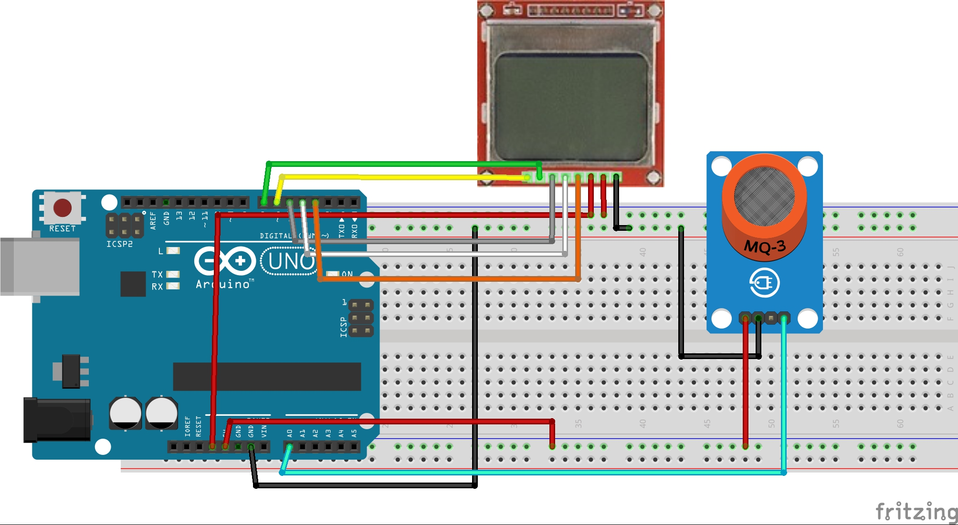
Follow bellow steps to make this project.
Step_1:PROGRAMMING
follow the code
Step_2:check all the connection and check correct port and board in tool menu.
Step_3: Now if you have done everything then it’s the time to upload the code in your Arduino board.
Result: After burning the code in your Board and making all the connection of project. You will see the Nokia LCD will get started and shows you message and then after the calibrating the R0 value it would show you LPG, CO and Smoke concentration in PPM (parts per million) on the LCD screen.
Whenever you will breathe out or put LPG gas or CO, its value would change on the screen.
When you exhale breathe on the sensor the values on the sensor does change and if you have cigarette lighter then the reading would be much higher.
Project specification:- LGP sensor detection or smoke or CO can be really a good project and you can learn many things from this project.MQ2 sensor sense LPG, CO, and Methane and Smoke so many homemade projects and product can be made.
MQ2 sensor is very interesting sensor and mostly used in factories and industries for detection of gas leakage and gas concentration in the chamber.
MQ2 gas sensor has many other siblings which work for different gases and all those are used for different purpose.
Projects which can be made with it: -
- LPG and methane gas leakage alarm system.
- Gas concentration measurement in any reaction chamber.
This project also can be interface with many other communication modules for transmitting information from one point to other like GSM module, X-bee module and Wi-Fi module.
Note: if you want to see these results on serial monitor of Arduino then you can upload MQ2_gas_sensor_on Serial monitor. And if you are using it as real time product for home then give power to MQ2 sensor external power source because it drain so much apm current and get heavily heated.

